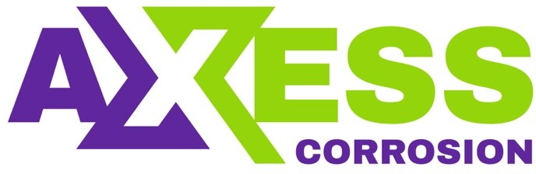

Daily Progress Report

Installation / Location | PS-3
Subject | Corrosion Monitoring Activities
Contract Number | LC241047A0
Assigned Axess Representatives | Stuart Dunthorne
Date of Issue | 08-07-2025

Activities Summary
We arrived at PS-3 this morning and completed all required inductions etc. We then proceeded with submitting two work permits and the Level 2 JSA. In the afternoon, we needed to meet with safety team, and permit authority to discuss all aspects of the job prior to their approval.
Later in the afternoon, we proceeded to site and performed visual inspection of the locations to confirm Tag ID’s and assess scaffolding requirements.
The retrieval equipment was not lifted off of the vessel this morning with us, as the vessel was required to proceed to priority work at a Well Jacket. The Radio operator confirmed that the vessel was planning to return to PS-3 to offload the equipment late afternoon or evening.

Time | Activities
06:00 to 08:30 | Proceed to dock, board vessel for PS-3
08:30 to 11:30 | Complete platform inductions. Submit 2 x Work Permits and JSA for approval
12:30 to 15:30 | Meetings with Safety team, permit controller & permit authority to discuss Level 2 JSA and work permit requirements
15:30 to 17:30 | Perform visual survey of all locations to confirm ID’s and asses scaffolding requirements
17:30 to 18:00 | Daily Reporting

Observations & Recommendations
As mentioned above, the equipment has not yet been loaded to the platform but hopefully by the morning it should be on-board.

24 Hour Lookahead
The plan for Wednesday 9th July is to complete the ER Probe readings and hopefully commence coupon retrievals on PS-3 C.

Stuart Dunthorne – Axess-Corrosion. – sdunthorne@axess.energy

